Exercise no:05 regno:1518102098

Date:15.10.20

**Aim**

To Write a Python function to print missing characters to make string pangram

**Program**

sentence = input()

sentence = sentence.replace("","")

alpha_flag =[0]*26

for char in sentence:

asci = ord(char)-97

alpha_flag[asci]=1

asci=0

for i in range(0,len(alpha_flag)):

if(alpha_flag[i]==0):

asci=i+97

print(chr(asci),end="")

**Link**

http://103.53.53.18/mod/vpl/forms/edit.php?id=235&userid=1703

**output**

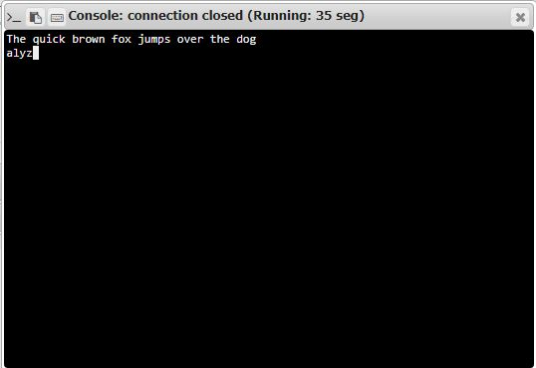

**Result**

Thus,the code has been sucessfully executed and output is verified.